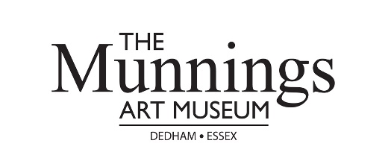
JOINING INSTRUCTIONS
Plein Air Masterclass / Painting Day
Mendham Mill, Mendham, Norfolk, IP20 0NN
Saturday 6th & Sunday 7th July 2019

Information
Masterclass cost: £90 per day (includes teaching, support and feedback throughout the day, lunch and refreshments)
Time: 9.30am – 4pm
Tutor: Malcolm Cudmore
The class is limited to 12 places.
The masterclass is suitable for complete beginners who are keen to learn the rudiments of painting outdoors.
Tea, coffee and lunch are provided in the grounds of Mendham Mill. There is also the Alfred Munnings pub in the village which is a 10 minute walk from the mill.
NOTE: we are also offering painting places only, limited to 25 people: £50 per day. Includes some feedback from the tutor, no refreshments provided.
The mill is privately owned and operates a number of holiday homes in the grounds. Please be respectful of the owner’s property and the privacy of the guests staying at the mill during the masterclass / painting day.
Directions to the mill can be found via their website: https://www.mendhammill.co.uk/

Malcolm Cudmore is a plein air painter, figurative artist and teacher. He is based in Bungay.

Payment terms and conditions:
Full payment is needed to secure your place on the Plein Air Masterclass / Painting Day.
In the event of you having to cancel your place we will issue a refund, minus 10% administration cost, up to and including Friday 24th May 2019 (six weeks prior to the event). After that date, we will refund 50% of the fee paid if we are able to refill the place.
Should we need to cancel the event, then a full refund will be issued.
PAYMENT DETAILS
Payment can be made:

- Online at https://www.munningsmuseum.org.uk/events-and-workshops/
- By card over the phone, Monday to Friday, 10am-4pm, 01206 322127 (option 4)
- By bank transfer to The Castle House Trust, Barclays: Sort Code: 20-22-67 Acc No: 20192902
- By PayPal invoice (please email accounts@munningsmuseum.org.uk to request an invoice)
- By cheque, payable to: Castle House Trust

Remittance: Plein Air Masterclass / Painting Day with Malcolm Cudmore (6th, 7th July 2019)

Name Telephone No
Email address
I have paid £90 / £180 / £50 / £100 / £140 Online (www.munningsmuseum.org.uk) Credit / Debit Card
Bank Transfer PayPal Cheque

Do you have any dietary requirements as lunch is provided for masterclass participants:

Please complete and return this form to the museum as soon as possible:
FAO Bookings
The Munnings Art Museum, Castle House, Castle Hill, Dedham, Essex CO7 6AZ
bookings@munningsmuseum.org.uk / 01206 322127

